**Meet Your Neighbor:**

**There's something fishy about Kay Young's art**

Sheri Trusty, Correspondent Published 4:30 p.m. ET July 8, 2018 |

Updated 4:36 p.m. ET July 8, 2018

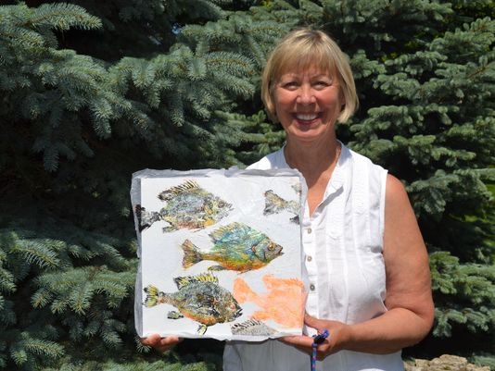  
(Photo: Sheri Trusty/Correspondent)

CONNECTTWEETLINKEDINCOMMENTEMAILMORE

CATAWBA - A Catawba woman has infused her own style into a traditional Japanese fish printing art form called Gyotaku. Kay Young utilizes local Lake Erie fish to create intricate, original works of art in her Catawba home.

Gyotaku is a traditional method of fish printing that was first practiced by Japanese fisherman to record their catches in the mid-1800s and is now a revered art form. The prints were originally simple black and white copies of the fish, but Young has added her own artistic style by painting the prints in a myriad of unique colors and applying a technique that gives the finished print a 3D appearance.

**How she does it**

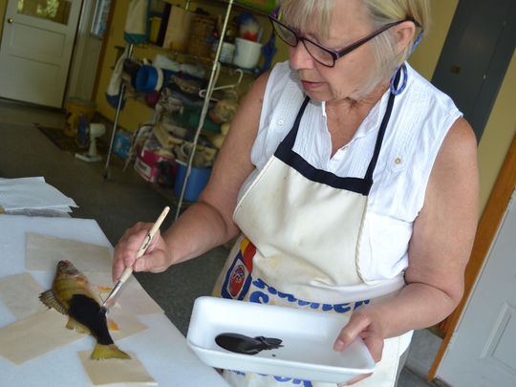

Kay Young adds acrylic paint to the perch. (Photo: Sheri Trusty/Correspondent)

Young begins her process by visiting Port Clinton Fish Company, whose employees graciously handpick fish for her projects.

“They will go back and get me a good fish. They are so nice,” she said.

Occasionally, Young uses fish caught by local friends in Lake Erie, including yellow perch, walleye, or sunfish.

Back at home, Young washes the fish to remove the mucus covering and places it onto a slightly hollowed out section of a Styrofoam board. “That gives me a flat surface to work on, and I use pins to stake down the fins,” she said. “I want an uneven surface on the fish, so I put bits of crumbled tissue paper under the gills and fins and in the mouth. I want his fins to stand up a little more.”

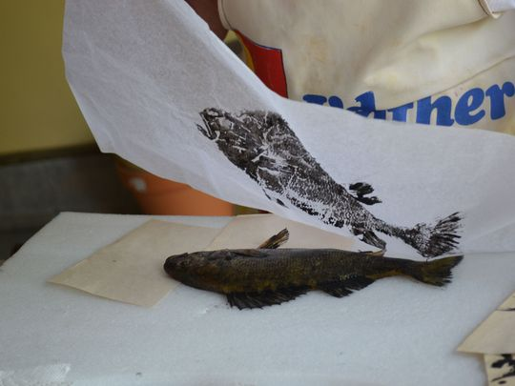

Kay Young lifts the tissue paper print from the perch. She often makes two or three more prints using the same ink to create lighter-colored prints for background images in her work. (Photo: Sheri Trusty/Correspondent)

From there, Young gently paints the fish with black acrylic paint, avoiding the eye area, which will be hand painted on the paper later in the process. A sponge is used to blend the paint to conceal the paint strokes.

Traditional Japanese works are printed on rice paper, which Young uses occasionally, but she prefers tissue paper. The tissue paper is carefully laid atop the painted fish, and Young uses a paintbrush to press the paper into the fish to transfer the image. The paper is removed, and the image is sprayed with alcohol.

“Alcohol dries fast and doesn’t rip the paper easily,” she said. “I’ll make several prints with each fish. I make one fish last — sometimes three or four days.”

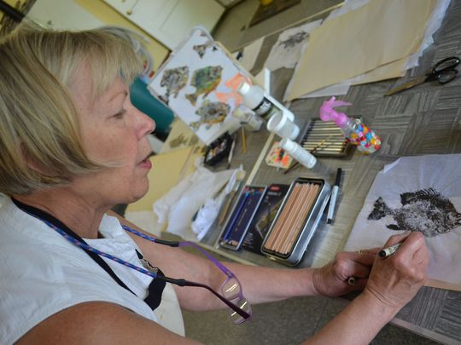

Kay Young makes changes and fixes smudges on the print. (Photo: Sheri Trusty/Correspondent)

Once the printed image is dry, Young decides how she wants the eyes — realistic, hollow, or, occasionally, with a yin-yang appearance — and uses a Micron pencil to draw them. Watercolor pencils are used to color the fish in bright, vibrant colors.

“I highlight spots on the fish, including the eyes, so it looks like light is shining on it,” she said.

Young’s final touch is to seal the print with an iridescent medium that picks up light and makes the fish look realistically shiny — so realistic that people have asked her if she uses real fish skin on the images.

When she is ready to mount the work, she places a bit of crumpled tissue paper under the body of the fish to create a 3-D look. Once it is mounted on canvas or, her preference, a solid board, she seals the work with Liquitex, which allows her to display the work without using a glass-fronted frame.

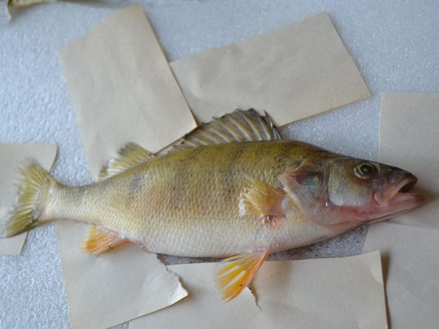

A yellow perch awaits the printing process at Kay Young’s garage. (Photo: Sheri Trusty/Correspondent)

“It dries clear,” she said. “Watercolor artists are starting to use it to cover their work so they don’t have to use glass.”

Each print is an original work of art using Young’s own Gyotaku-inspired process.

“I’m pretty sure that no one else does this. It came out of my head,” she said.

Young sells her prints out of her Catawba home and occasionally at local craft shows; she will sell her prints at the Lakeside-Marblehead Lighthouse Festival in October. For information on purchasing Young’s fish prints, contact her at 419-260-3335 or at kayyoung200@gmail.com.

*Contact correspondent Sheri Trusty at sheritrusty4@gmail.com.*

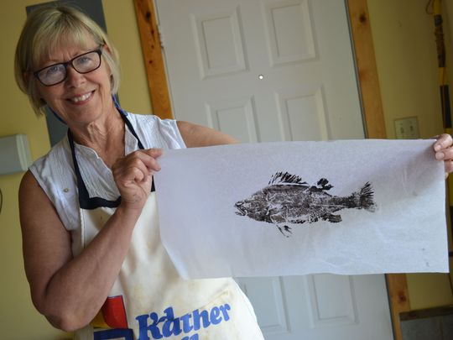

Young with a pre-colored print. (Photo: Sheri Trusty/Correspondent)